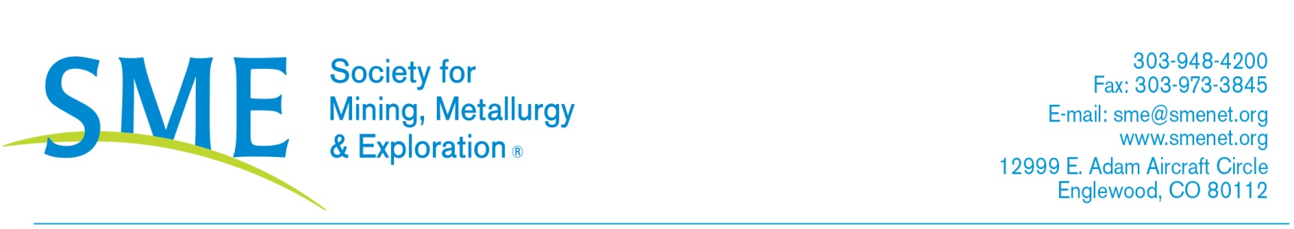
Dear <Manager>:

I would like to <join or renew my membership with> the Society for Mining, Metallurgy & Exploration (SME). This membership <enables or will enable> me to gain valuable insights about key issues central to the mining industry while also giving me access to numerous resources and the opportunity to connect with leading industry experts. I am seeking your approval for the annual membership dues of $<your dues amt.>.

Benefits of joining SME that will support my position at <Employer Name>:
- Professional Development Opportunities
  - Cutting-edge conferences, webinars, publications and books at discounted rates
  - Monthly subscriptions to Mining Engineering magazine, Mining, Metallurgy & Exploration journal, and unlimited access to Onemine.org database
- Networking Opportunities
  - Access to industry subject matter experts at conferences and through the SME online Community
  - Online engagement tools, including an online member directory
  - Volunteer and leadership opportunities

As a result of my membership, I will have access to unparalleled educational opportunities that can immediately be put to use with <project(s) you are working on or functional job area>. I’ll use my membership to connect with mining industry professionals dealing with similar challenges.

The opportunity for me to develop better contacts with industry experts and network in this professional association will help me gain knowledge in specific area of <insert your field>. My membership with SME is a wise investment and will help me take our company to the next level.

Feel free to contact SME for more information on how this membership will benefit my growth as an employee of <Employer Name>.

Laura Nelson, SME Membership Manager
303-948-4204

Thank you for your consideration of supporting my success with a SME membership.

Sincerely,
<Your Name, Title>

