Class of 2022
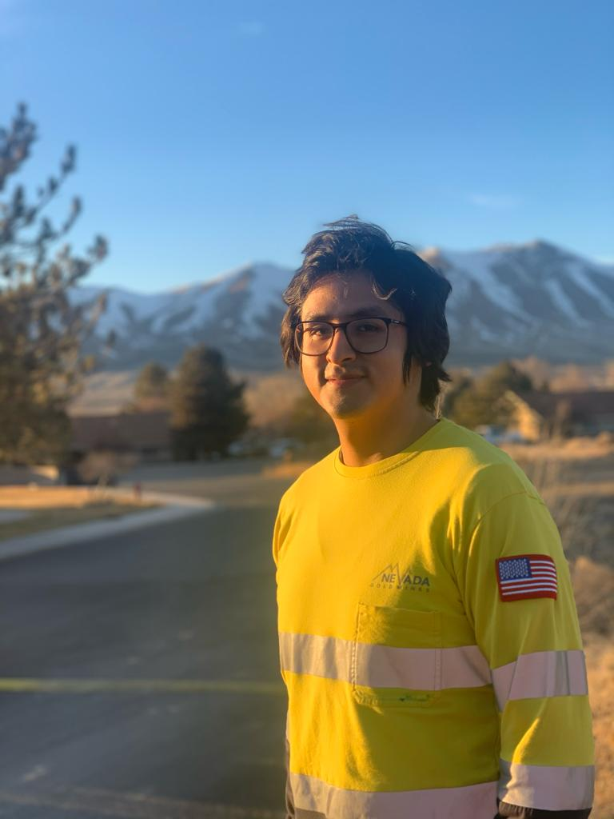  Alvar J. Marin  Alvar J. Marin was born in Lima, Peru, on November 25, 1995. He attended the Peruvian University of Applied Sciences (UPC) in Lima, Peru, and completed his bachelor’s degree in Mining Engineering and Management in 2017. Mr. Marin was a member of the academic excellence group of UPC and graduated with honors. Mr. Marin decided to pursue his master’s degree at South Dakota School of Mines & Technology.  Throughout the years, Alvar’s career has had a focus on mine planning with his current role being a short range / long range engineer at Nevada Gold Mines. He has experience with forecasting, developing a business plan, and developing/communicating engineering plans, pattern designs, sequences, and dumping priorities to the mine’s stakeholders.  Mr. Marin enjoys photography, hiking and traveling. | 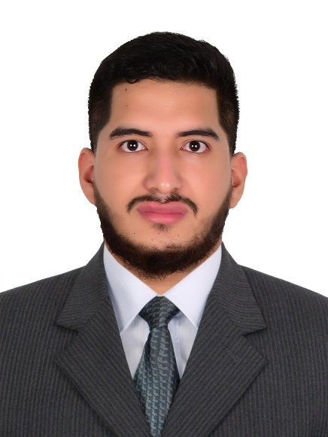  Armats Giarnelly Quinones  Armats Giarnelly received his bachelor’s degree in Mining Engineering from National University of Engineering in 2021. As a student SME member, he participated in the third Mine Planning Design Contest (2019) organized by SME Latin America and took the first place with his team, thus he went SME Annual Conference (2020) in Arizona. Also, he took part in the 2021 MPD Student Video Contest getting the third place. He has 3 years of experience in mine planning, mine operation and exploration. He worked in mining companies such as San Ignacio de Morococha, Chinalco, MMG Las Bambas, Freeport-McMoRan Inc. Currently, he is a mining consulting serve the role mine planning engineer.
Diana Rodriguez  Diana Rodriguez has a degree in chemical & biological engineering with experience in the design, data analysis, reporting of metallurgical testing campaigns, and modelling precious metals recovery. Diana has developed diffusion modelling analyses and produced recovery estimations utilizing MATLAB software. Diana has developed documentation and procedures for test work, in addition to general laboratory processes. She currently facilitates and manages metallurgical testing campaigns, including conducting sample preparation and test work. She is experienced in equipment cost estimations and budgeting, as well as establishing health and safety protocols surrounding cyanide and reactive chemicals. Her interests include minerology and she has earned a minor degree in Geology. | Jiajia Wu  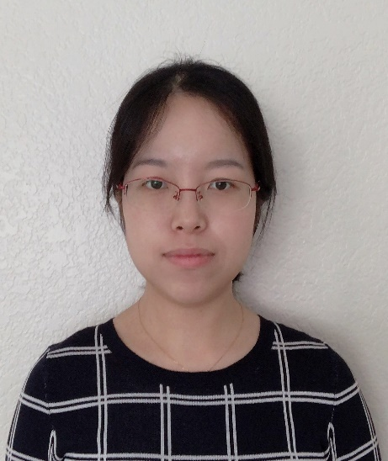  Jiajia Wu is a research engineer at Forte Analytical, working on various R&D research projects regarding gold extraction. She received PhD degree in Extractive Metallurgy from the University of Arizona in May 2021. She earned her BS and MS degree from Central South University in Changsha, China in Mineral Processing and Extractive Metallurgy. She was a recipient of Graduate College Fellowship from College of Engineering in 2017 and she also won 1st place award on MPD poster competition in 2019 SME annual conference. Her research interests are hydrometallurgical processes of copper and gold and metal recycling from secondary resources.
Maddie Orrell  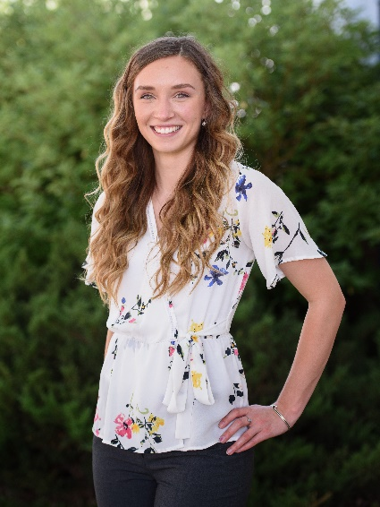  Maddie Orrell graduated from Montana State University with a Bachelor’s in Chemical Engineering. During her time throughout college, she experienced hands-on experience with hydrogen fuel cells and anodizing processes, pivoting to a career in mining at, metallurgical lab, Forte Analytical, LLC. As a project manager for Forte, her focuses include individualized studies of cyanide leach processes mainly for gold and silver extraction as well as developing her geotechnical testing skills. | Sayuri Nahomi Caururo Norbuena  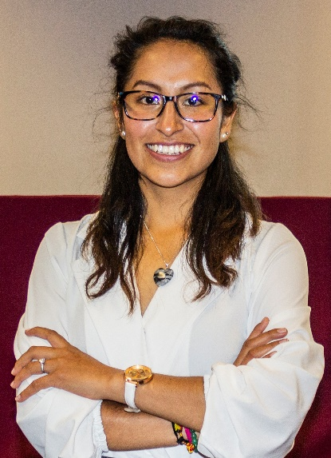  Sayuri N. Caururo is a professional graduate of the Mining Engineering career at the Santiago Antunez de Mayolo National University - UNASAM. In addition, She is a Technical Office Assistant at Maccaferri Construction. She is the founder and director of Red de Ingenieras de Minas- RIM Peru, Ambassador OMA Peru in Ancash, Executive Women in Women for Safety, Mentor in Women Can Do Peru, Mujer Roca promoted by the Chamber of Commerce Cánada - Perú. Sayuri has a great passion for the mining sector and a strong sense of safety, social responsibility, and mining operations. In addition, it presents great management of interpersonal relationships, ease of taking initiative in any activity carried out, and has extensive experience in leadership, systemic thinking, design thinking, innovation, and organization. She says: "Learn how to make the Phoenix rise from your own ashes"

